**Setting up Master Page with frozen header (includes bootstrap)**

Go to “Site Settings” and under “Web Designer Galleries” area click on “Master pages and page layouts”. Create a new folder called ShareBoot. Of course you could call it whatever you like, which I don’t recommend until you’re familiar with the theme because you’ll have to change all the reference links in the theme, but for the purpose of this tutorial I will refer to as ShareBoot folder.

Inside ShareBoot folder create four folders called: css, images, fonts and js. Next, upload the necessary files provided in the ShareBoot package.  
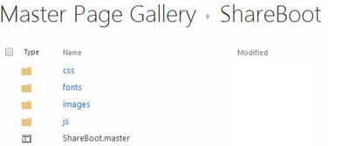

First, upload the main CSS file, ShareBoot.css under the newly created css folder. Click on the Files tab on the ribbon, and click “Upload Document”. On the pop-up window make sure you select “Design File” for the Content Type and hit Save button.  
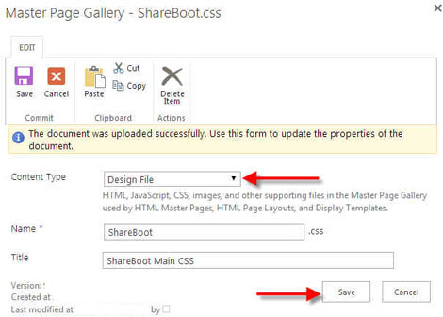

Same rules for all the design files (css, images, fonts and js).

Make sure you publish each updated design file by selecting from the drop-down menu “Publish a Major Version”.  
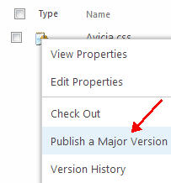

Next, upload ShareBoot.master right under ShareBoot folder by selecting Files tab on the ribbon and then “Upload Document”. On the pop-up window make sure you select “ASP NET Master Page” for the Content Type, give your master page a name and a title, select version 15 and hit Save button.  
